

**MAHARASHTRA STATE BOARD OF TECHNICAL EDUCATION (MUMBAI)**

**INDUSTRIAL TRAINING REPORT**

On

**“R3 SYSTEMS INDIA PVT.LTD”**

In partial fulfillment for the Completion of course

**Industrial Training - 22057**

in the Programme

**Computer Technology**

****At

**K. K. WAGH POLYTECHNIC, NASHIK**

**Academic Year 2023-24**

NNN

**Submitted By:**

Name: Aditya Arun Dhakane

Seat No.____________

**K. K. Wagh Polytechnic, Nashik.**

Hirabai Haridas Vidyanagari, Amrutdham, Panchavati, Nashik-422003

**Department of Computer Technology**

**CERTIFICATE**

This is to certify that Mr. Aditya Arun Dhakane studying Diploma in Computer Technology, K. K. Wagh Polytechnic, Nashik has undergone 6 weeks Industrial Training during the period from 07/06/2023 to 23/07/2023 in our R3 System India Pvt.Ltd. Industry as a Partial Fulfillment for the award of the Diploma Engineering in Computer Technology. He was trained in the field of Web Development.

We observed that the student is having hard working nature and sincere during the training period and wish him for better prospects in studies as well as career.

**Signature & Seal of Trainer/ Industry Supervisor**

**INDEX**

|  |  |  |
| --- | --- | --- |
| **Chap No.** | **Title of Chapter** | **Page No.** |
| **1.** | **Introduction to Industry/Organization and its Organization structure** | **4-6** |
| **2.** | **Types of Software tools used with their specification** | **7-8** |
| **3.** | **Training course contents/outline/syllabus** | **9-10** |
| **4.** | **Summary of each Topic/Subtopic of course contents** | **11-12** |
| **5.** | **Assignment/Quizzes/Exam elaboration and Summary table** | **13-15** |
| **6.** | **Particulars of practical Experiences in industry** | **16** |
| **7** | **Short report/Description of the project** | **17-21** |
| **8** | **Special/Challenging experiences encountered during training** | **22** |
| **-** | **Conclusion/References** | **23** |

#### Chapter 1

**INTRODUCTION TO INDUSTRY & ORGANIZATION STRUCTURE**

We at R3 Systems are a group of IT experts, R3sys is a graceful and lean product development and IT service provider. We develop as well as co-develop mobile application, web portals and analytics solutions. In this advance world, R3sys is always there to help you to go through these IT challenges and get connect you to the world in most efficient manner. We are building our skill sets to find the defects in the current market an correct them with our unique solution of what a real satisfying business relationship should be like.

R3 Systems wanted to bridge the gap where most outsourcing companies fail with their customers, we have managed successfully to so that.

* **COMPANY/ INDUSTRY PROFILE: -**
* **Name of the Company** :- R3 SYSTEMS INDIA PVT.LTD
* **Location/ address** /**Pin code** : - First Floor, Rohini Apartment, KBTCircle, GangapurRoad, NearSaraswatBank, ThatteNagar, Nashik,Maharashtra- 422005,India
* **Establishment** : - 2017
* **Email & Web Address** :- india.r3sys@gmail.com https://www.r3sys.com/
* **Name and Designation of Contact Person:-** Mr. Gauresh Suryawanshi (Chief Technical Officer)
* **Contact No:-** 8600033181
* **Type of Product:-** ( IT Software Development & Consultancies)
* **Type of Control :-** (Private )
* **Type of Company :-** (Small Scale )
* **Total Number of Employees in Company :-** 30
* **Total Turnover of Company :-** 20 Lakh
* **SERVICES PROVIDED BY R3 SYSTEMS:**
* Web Design & Development
* Mobile App Development
* Digital Marketing
* Project Consulting
* Corporate Training
* **ORGNISATIONAL STRUCTURE OF INDUSTRY**

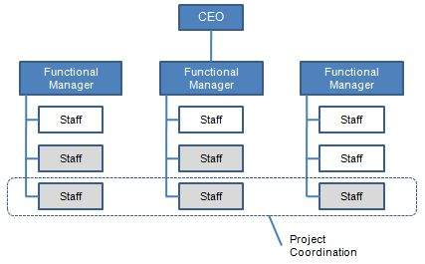

* **GENERAL LAYOUT OF THE INDUSTRY/ORGNIZATION:**

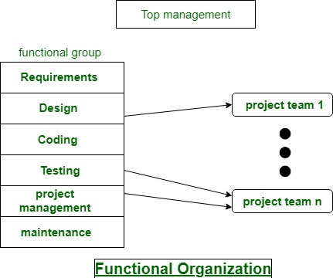

**History:**

R3 Systems is established in 2017, till now worked for 30+ clients and our team has more than 4-5 years of experience. We are building our skill sets to find the defects in the current market an correct them with our unique solution of what a real satisfying business relationship should be like. R3 Systems wanted to bridge the gap where most outsourcing companies fail with their customers, we have managed successfully to so that.

**Chapter 2**

**TYPES OF SOFTWARE TOOLS USED WITH SPECIFICATION**

**2.1.1. Laptops**

**Specification**

* Processor: up to Intel Core i5-2410M 2.3 GHz.
* Graphics: ...
* Memory: up to 8GB DDR3.
* Storage: up to 750GB hard disk drive.
* Optical Drive: a dual layer DVD reader/writer.
* Display: 15.6" (HD, maximum resolution of 1600 × 900)
* Web Camera: integrated.

**2.1.2 XAMPP**

The XAMPP application for Local hosting of Websites. XAMPP has the ability to **serve web pages on the World Wide Web**. A special tool is provided to password-protect the most important parts of the package. XAMPP also provides support for creating and manipulating databases in MariaDB and SQLite, among others.

**2.1.3 Eclipse**

Eclipse is a free, Java-based development platform known for its plugins that **allow developers to develop and test code written in other programming languages**. Eclipse is released under the terms of the Eclipse Public License.

**2.1.4 Wordpress**

WordPress is **a content management system (CMS) that allows you to host and build websites**. WordPress contains plugin architecture and a template system, so you can customize any website to fit your business, blog, portfolio, or online store.

**2.1.5 Approximate cost and specific use and their routine maintenance:**

**Laptop Cost:** 32,000 (Number of Laptop 10)

XAMPP, Android Studio, Eclipse, Wordpress and Mysql software are open Source.

**Chapter 3**

**TRAINING COURSE CONTENTS/OUTLINE/SYLLABUS**

* 1. **Course contents/outline/syllabus:**

1. **Introduction to Software**
   1. What is software?
   2. Types of software
2. **Web Application Development**
3. Introduction to Web Application Software.
4. Importance of Web based application in industry.
5. Different Languages to develop the Web Application Software.
6. **Introduction to Core JAVA**
7. Introduction to java
8. Decision making statements
9. Looping Statements
10. Classes and Objects
11. Methods
12. different OOP concepts
13. Collection Framework
14. **Introduction to advance JAVA**

1.Introduction to Advance java

2.Introduction to Servlets

3. Introduction to JDBC (java database connectivity)

4.Application

1. **Servlets and JSP concepts**

1.Handeling the Servlets

2.Embedding java in html using JSP

1. **Web Based Languages (HTML, CSS)**

1. Introduction of HTML

2.Introduction to CSS

1. **Application**

1.Application

2.Implementation

**Chapter 4**

**SUMMARY OF EACH TOPIC/SUBTOPIC OF COURSE CONTENT**

* 1. **Summary of Contents:**

**1. Introduction to software**

Software is **a set of instructions, data or programs used to operate computers and execute specific tasks**. It is the opposite of hardware, which describes the physical aspects of a computer. Software is a generic term used to refer to applications, scripts and programs that run on a device. Softwares are categorized in multiple types, i.e. web application, mobile application, Real time, product based, etc.

1. **Web Application Development**

A Web application (Web app) is **an application program that is stored on a remote server and delivered over the Internet through a browser interface**. Web services are Web apps by definition and many, although not all, websites contain Web apps. According to Web.

Web applications include **online forms, shopping carts, word processors, spreadsheets, video and photo editing, file conversion, file scanning, and email programs such as Gmail, Yahoo and AOL**. Popular applications include Google Apps and Microsoft 365.Developed by using either java or .net.

1. **Introduction to Core JAVA**

Java is **a widely used object-oriented programming language and software platform** that runs on billions of devices, including notebook computers, mobile devices, gaming consoles, medical devices and many others. The rules and syntax of Java are based on the C and C++ languages.

Java is **a widely used object-oriented programming language and software platform** that runs on billions of devices, including notebook computers, mobile devices, gaming consoles, medical devices and many others. The rules and syntax of Java are based on the C and C++ languages.

1. **Introduction to advance JAVA**

Advanced Java is **everything that goes beyond Core Java** – most importantly the APIs defined in Java Enterprise Edition, includes Servlet programming, Web Services, the Persistence API, etc. It is a Web & Enterprise application development platform which basically follows client & server architecture.

1. **Servlets and JSP concepts**

Servlet is **a class that handles requests, processes them and reply back with a response**. For example, we can use a Servlet to collect input from a user through an HTML form, query records from a database, and create web pages dynamically.

JSP is used **to create dynamic web content**. In this JSP tags are used to insert JAVA code into HTML pages. It is an advanced version of Servlet Technology. It is a Web based technology helps us to create dynamic and platform independent web pages.

1. **Web Based Languages (HTML, CSS)**

HTML (Hyper Text Markup Language) is **the code that is used to structure a web page and its content**. For example, content could be structured within a set of paragraphs, a list of bulleted points, or using images and data tables.

Cascading Style Sheets (CSS) is **a stylesheet language used to describe the presentation of a document written in HTML or XML** (including XML dialects such as SVG, MathML or XHTML). CSS describes how elements should be rendered on screen, on paper, in speech, or on other media.

1. **Application**

By using Java,Html,Css we can develop a variety of applications such as **enterprise applications, network applications, desktop applications, web applications, games, android app**, and many more. In this section, we will focus on what is Java used for, the applications of Java, and why we use Java.

**Chapter 5**

**ASSIGNMENTS/QUIZZES/EXAM ELABORATION AND SUMMARY TABLE**

**5.1 Assignment:**

**1.Banking Application:**

This is dynamic web application which handles database , servlet and JSP pages. Frontend is developed with Html, css and javascript. In backend there is MySQL database. In this application you can perform different operations like adding/registering new user, deleting the user, updating the user’s information, etc. This bank application provides you faculties to adding new account in bank, depositing the money, withdrawing the money, deleting the accounts and view the accounts.

Features:

1. Sign-in/sign-up
2. Resetting the password
3. Creating new account
4. Depositing the money
5. Withdrawing the money
6. Deleting the accounts
7. View the accounts
8. Slideshow photo gallery
9. Information of banking terms with multimedia
10. Logging off

**Output:**

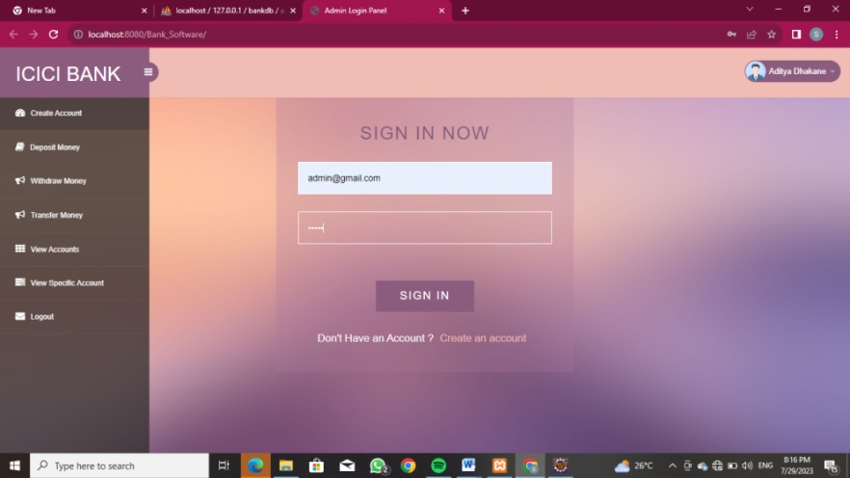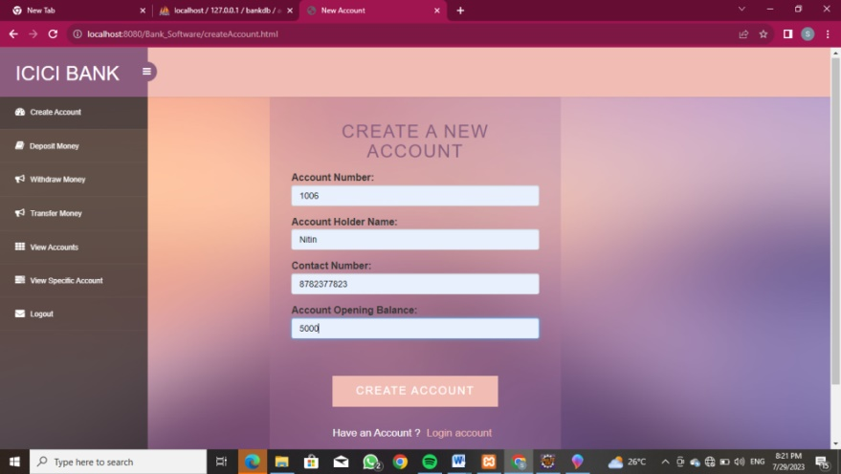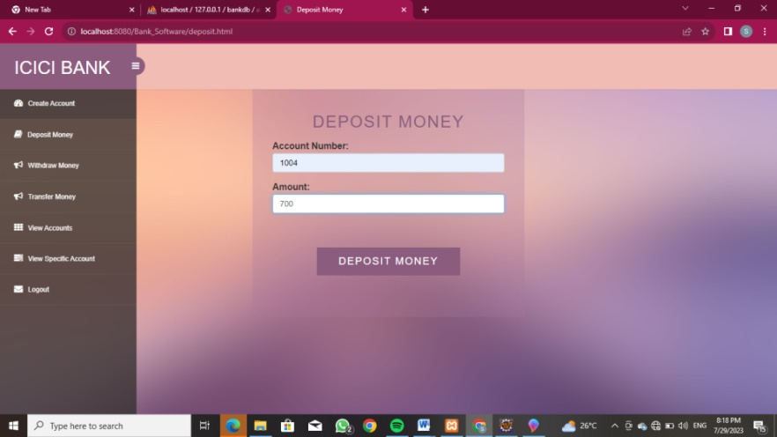

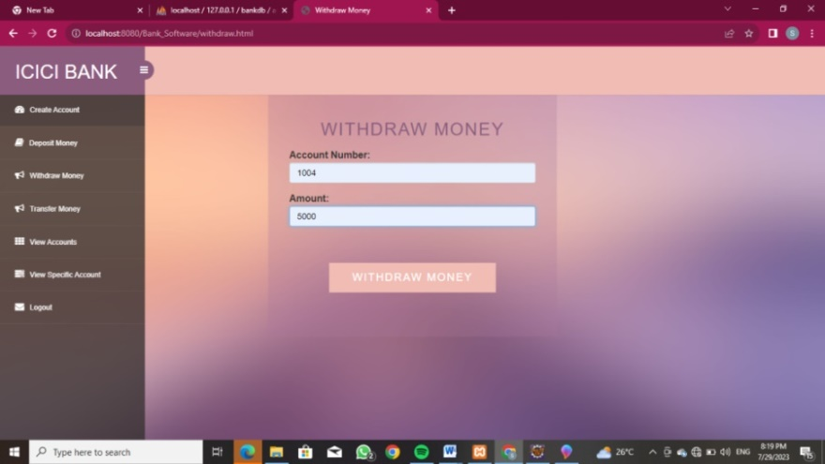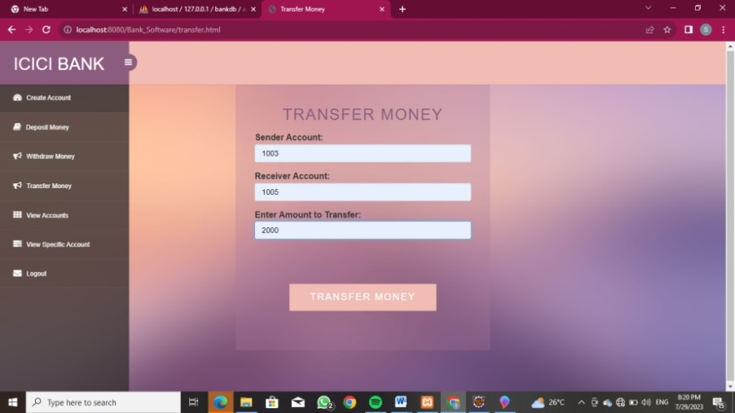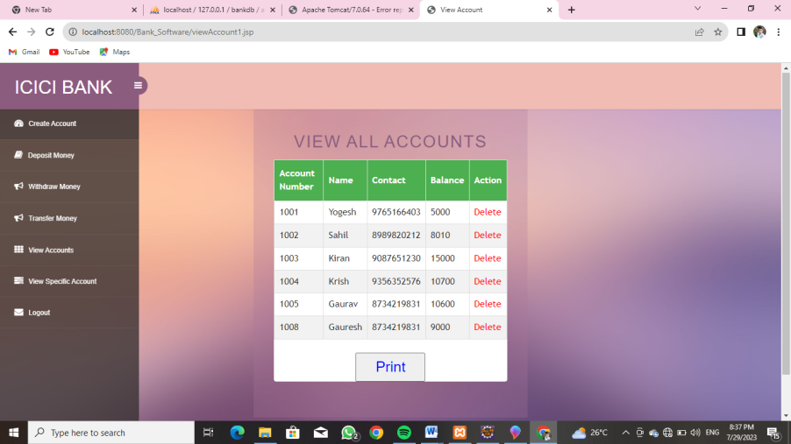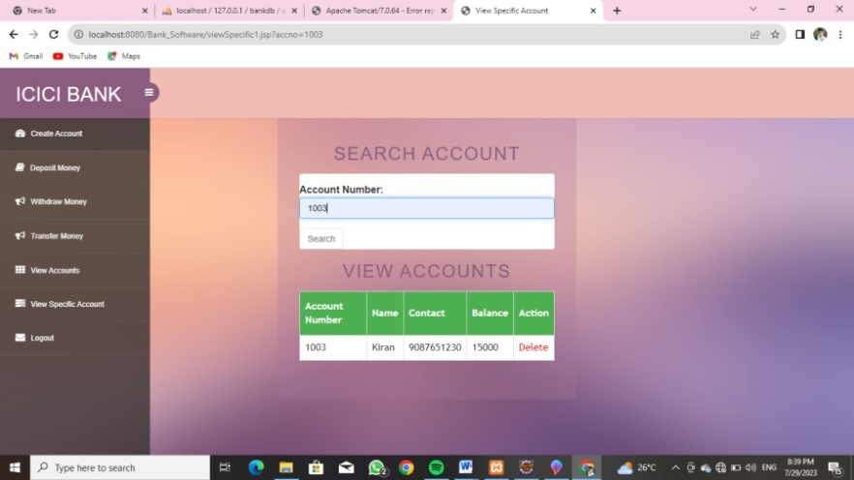

**Chapter 6**

**PARTICULARS OF PRACTICAL EXPERIENCES IN INDUSTRY**

**6.1.1 Projects**

1. Login template

2. Admission Registration template

3. Manipulation of data in table

4. Database handling

5. Banking application

6. Student Record application

7. Electric Vehicles charging station service application

**Chapter 7**

**SHORT REPORT/DESCRIPTION OF THE PROJECT**

**Electric Vehicle Charging Service Application:**

EV charging service application is dynamic web application which provides EV charging related services to the user. As we know the popularity of Electric Vehicles are increasing day by day, peoples are buying Electric vehicles more and more. To make this service more easier this application will definitely helps.

Languages used:

1. Java (Servlet and JSP for jdbc connection)
2. Frontend – HTML , CSS and JavaScript
3. Backend – MySQL

Features:

1. Three different modules ( Admin, CNG pump and users)
2. Each containing Registration/Login/resetting password
3. Different facilities are provided to different user
   1. Admin- view and deleting EV charging stations
   2. EV Charging Station - update the charging, view the charging stations
   3. User- view the EV charging stations
4. Handling and managing Projects
5. Managing the data and information given by different user

**Output:-**

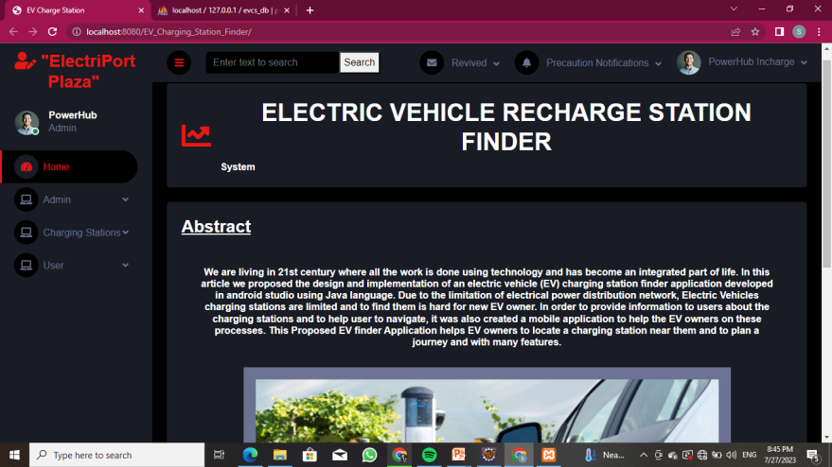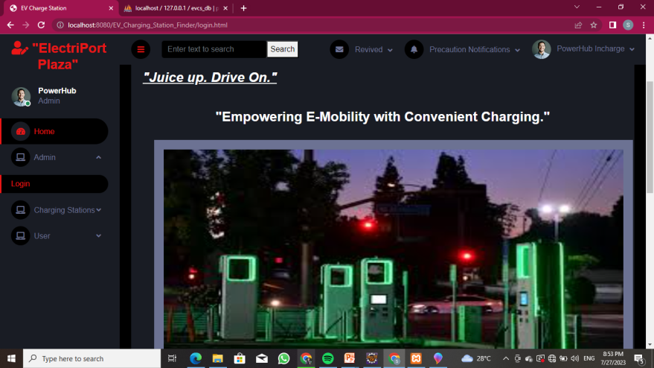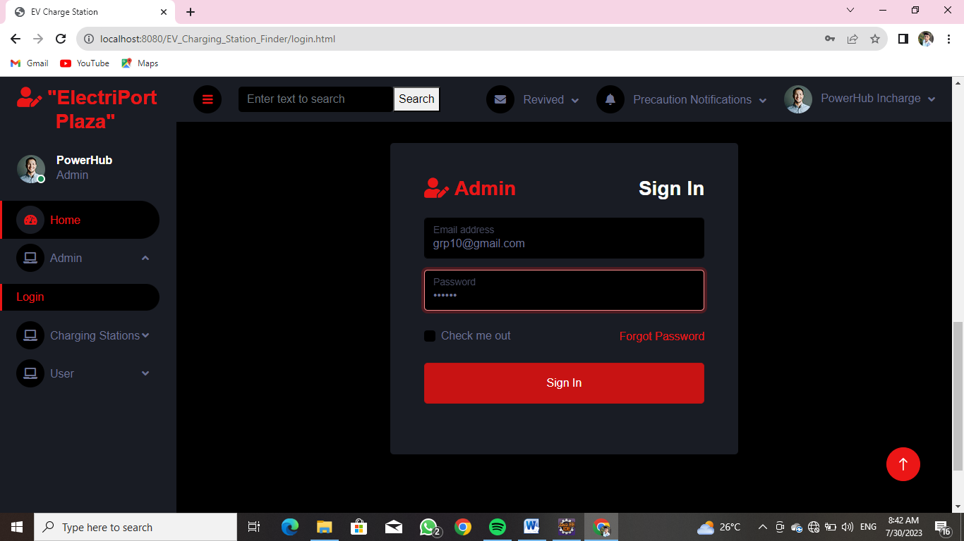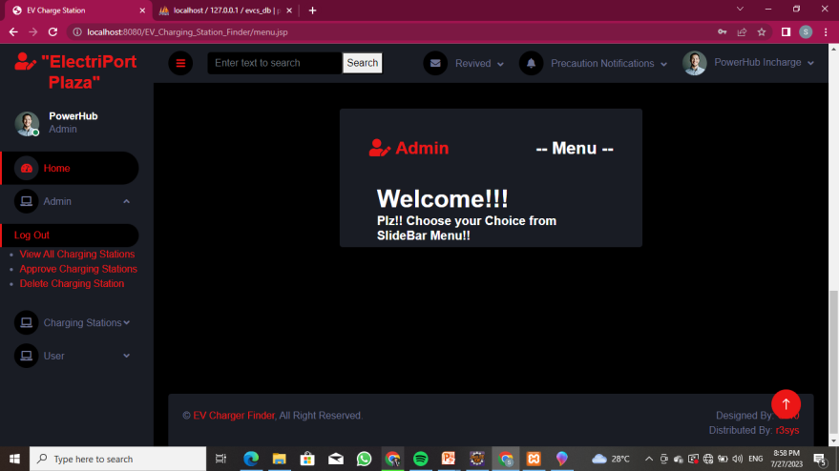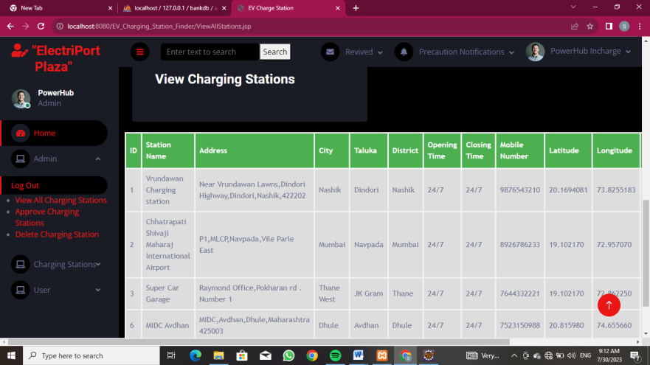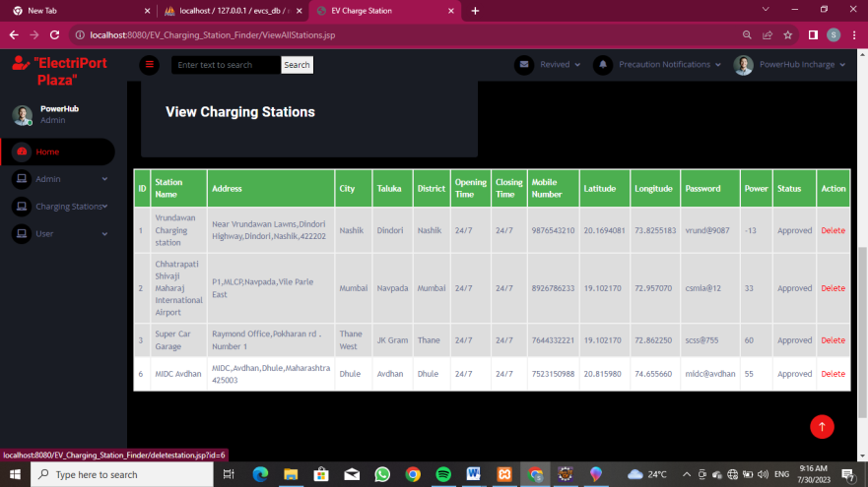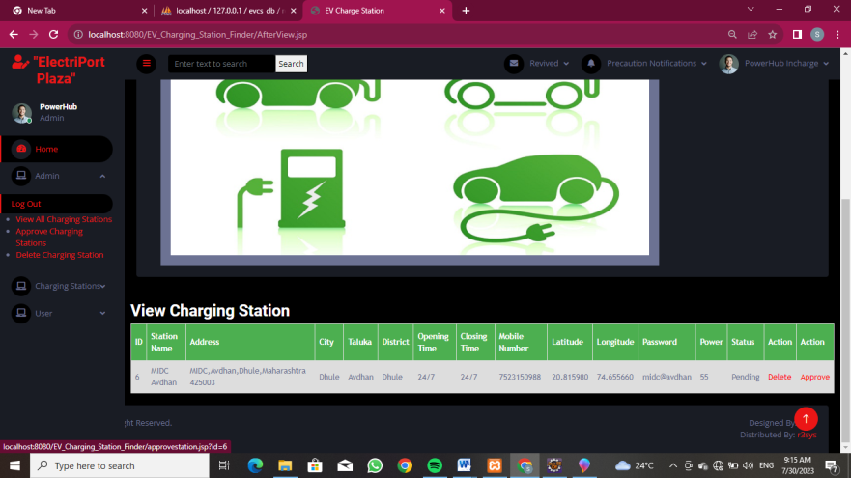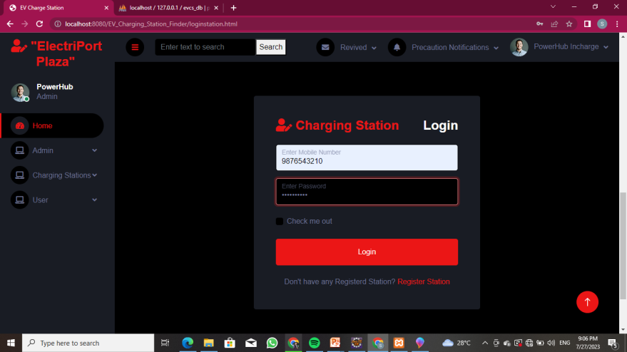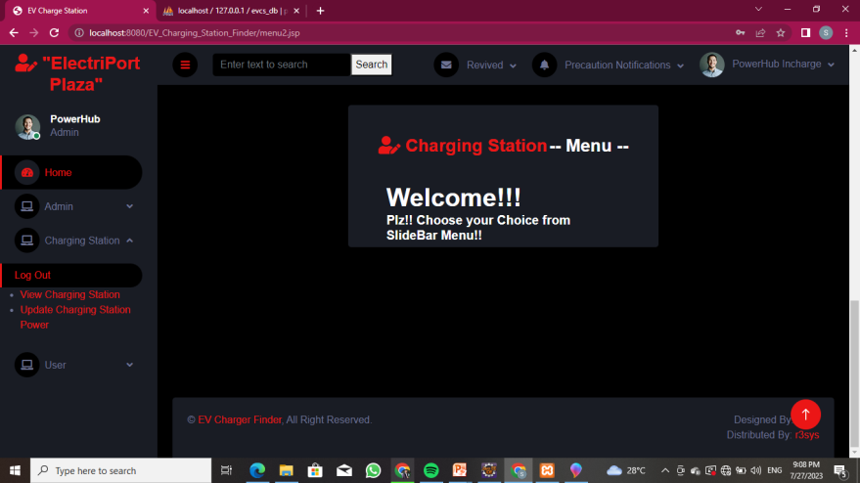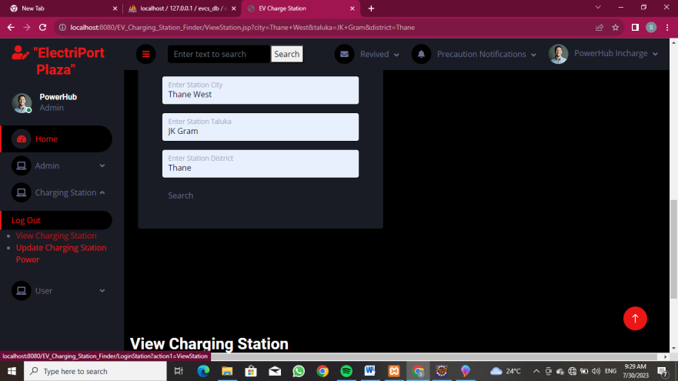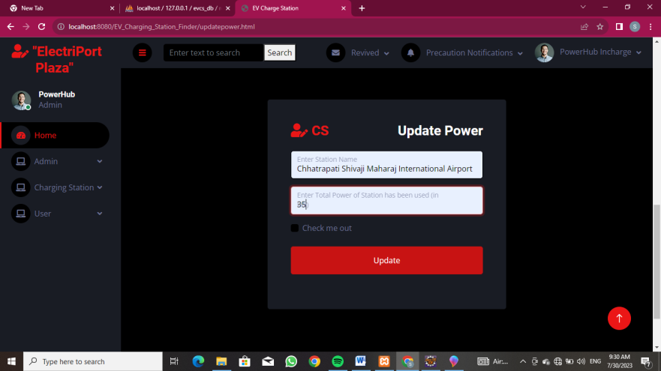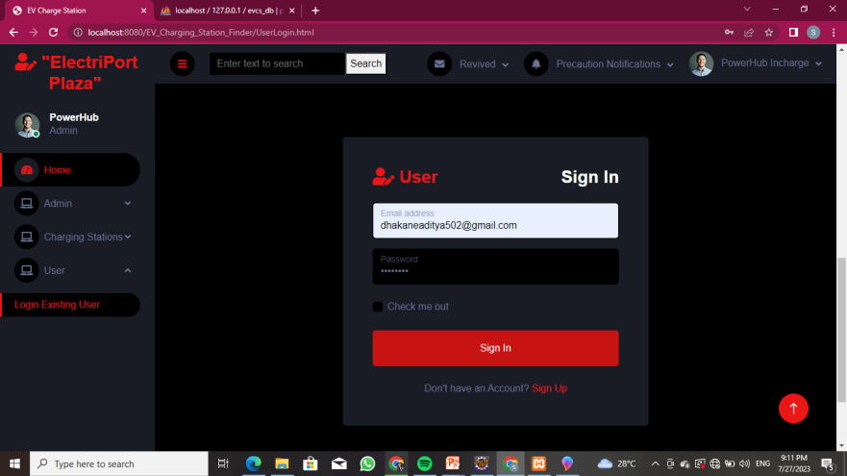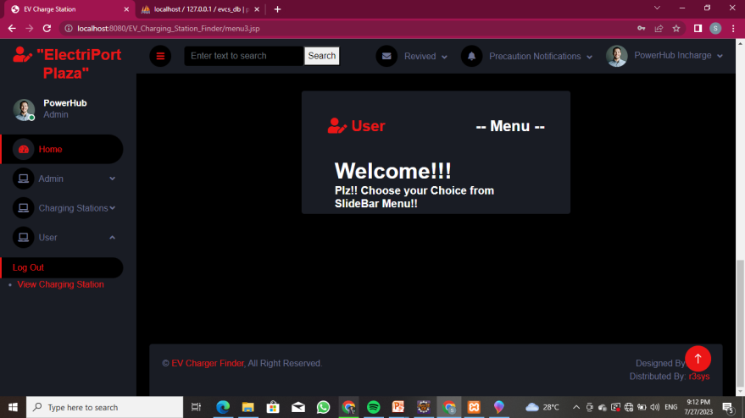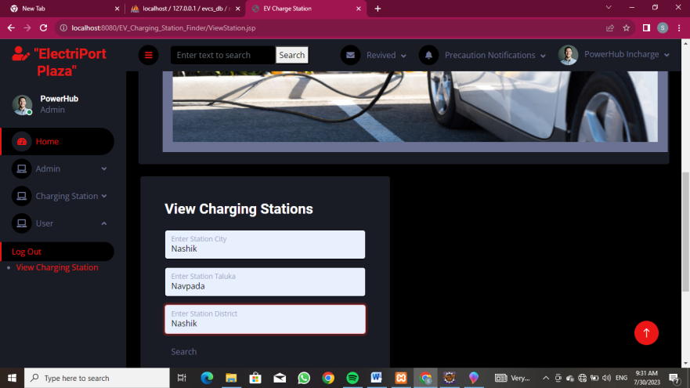

**Chapter 8**

**SPECIAL/CHALLENGING EXPERIENCES ENCOUNTERED DURING TRAINING**

**8.1.1 Experienced challenging and special experiences:**

* Time-consuming training creation.
* Use of advanced training tools.
* Manual delivery of quizzes.
* Outlining Training Content.
* Keeping the learners engaged.
* Boring course templates.
* Information overload.
* The need for peer collaboration
* Learning new things in new day
* Working with group of co-members

**Conclusion:-**

It was good & memorable experience of the 6 weeks in the company. During the training I got technical & practical knowledge in fact it was opportunity to me to observe, how the various departments co-ordinate in between them & how they were trying to plan, organize, control & manage the work properly to achieve the organizational goals

I am very thankful to my college and industry for making me familiar with industrial environment.

**References / Bibliography:**

R3 SYSTEMS INDIA PVT.LTD

**Physical location:**

First Floor,Rohini Apartment, KBT Circle, GangapurRoad, Near Saraswat Bank, ThatteNagar,Nashik,Maharashtra- 422005,India